**Running ADCVD Automation Scripts**

1. Download the script into your local from Github or SharePoint locations below:

**SharePoint:**

<https://itaisinternationaltrade.sharepoint.com/sites/adcvd/Shared%20Documents/Forms/AllItems.aspx?id=%2Fsites%2Fadcvd%2FShared%20Documents%2FAutomation%2FADCVD%20Scripts>

**GitHub:**

<https://github.com/InternationalTradeAdministration/automation.git>

Below are the created scripts for ADCVD:

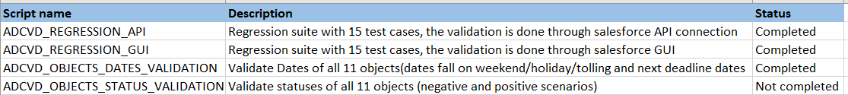

1. Set up the environment where the script will be running

The setting file is located at **<root folder>/settings.txt**

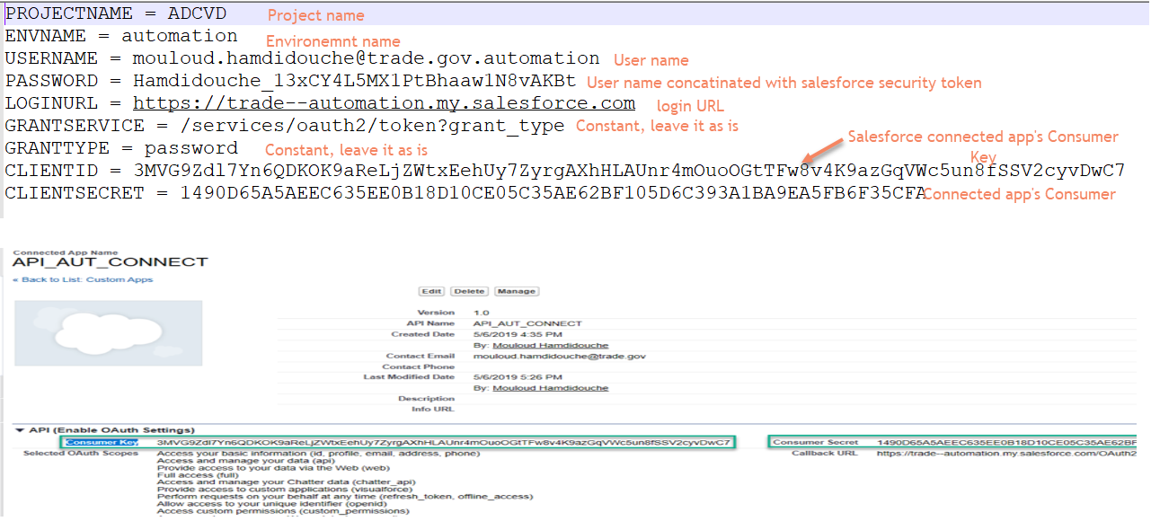

1. Run the script

* **From windows:** Double click on the batch file **<root folder>/ExecuteTestSuite.bat**
* **From Mac:** Navigate to the <root folder> of the script from Terminal and execute the .jar file inside using this command (java -jar filename.jar).

1. Explore the results: every time we run the script, a folder with time stamp will be created at

**<root folder>/output_results**, just click on the **results.html** inside the created folder and you see the results